**Brick Breaker Game**

**A Project Report**

***Submitted by***

**Vivek Shukla[17BCS2130]**

***in partial fulfillment for the award of the degree***

***of***

**BACHELOR OF TECHONOLOGY**

**IN**

**COMPUTER SCIENCE AND ENGINEERING**

**At**

**July,2019**



**ABSTRACT**

In our day to day life we are always busy and stressed because of work and rush of the modern world. So, we made a game just enjoy and spend some time to relax and chill out of the busy world. We made a typical brick breaker game coded in java, in which the user has to destroy all the bricks present in that level using the ball. The main aim of the player to is to control the ball using the paddle at the bottom. The player will have to move the paddle using left and right arrow keys to move the paddle and save the ball from going out of the frame. In this project we have used the java as our main program language and for the backend we have used the oracle database for storing and updating player’s scores.

**Acknowledgment**

We would like to express our special thanks of gratitude to our teacher Ritu kumari who gave us the golden opportunity to do this wonderful project on Brick breaker game, which also helped us in doing a lot of research and we came to know about so many new things, we really thankful to them. Secondly, we would also like to thank our classmates who helped us a lot in finalizing this project within the limited time frame.

**1. Introduction**

**1.1 Problem Definition**

This project is aimed to build a classic video game named Brick Breaker. We made an interactive game based on this. The objective of brick breaker is to break the bricks that are distributed around the top of the game screen. The bricks are broken after coming in contact with a ball that bounces around the screen.

**1.2 Project Overview**

The game consists of 5 levels in total. The player will be given 3 life in a session to complete the game. If the player loses his life in between these 5 levels then the game will be restarting from the respective level where the player lost their life. The main aim of the player is to break the brick with moving ball by controlling the ball with paddle provided at the bottom. The player has to destroy all the brick present in the level to complete the respective level completely. In our implementation, we have set the no of hits predefined with the color of the brick. For example, blue brick will be completely destroyed in 4 hits, red brick will be destroyed in 3 hits, likewise green in 2 hits and at last white brick in only one hit. The player has to use the left and right arrow key to control the paddle. If the player fails to control the ball from moving it outside the frame then the player will lose their life and the respective level will be get started again. If the user wants to quit the game then can press ESCAPE key any time to quit the game and the score will be saved in the database table.

**1.3 Project Design**

The project is designed in a very efficient way and in a very user friendly. This is done so to run the application in a very smooth manner. Also, the user who will use this application must not feel any difficulty to use it. The project is developed in the JAVA programming language consisting 8 different classes. First class i.e. named Main extending the JFrame class is the class which contains the main method and creates the frames to add the panel class into it. Other five classes are for the five levels each defining each level’s specification respectively. Also these five classes are extending Jpanel class that will be added to the frames when the respective levels are achieved by the player. The remaining two classes are accessed by the main frame only when the defined buttons were clicked by the user. The two classes are High Score and Instructions. The instructions class show the instructions how to play the game, control of the game etc. The High Score class will show the top ten high scorers along with their name and score. The data will be fetching from the database of the computer.

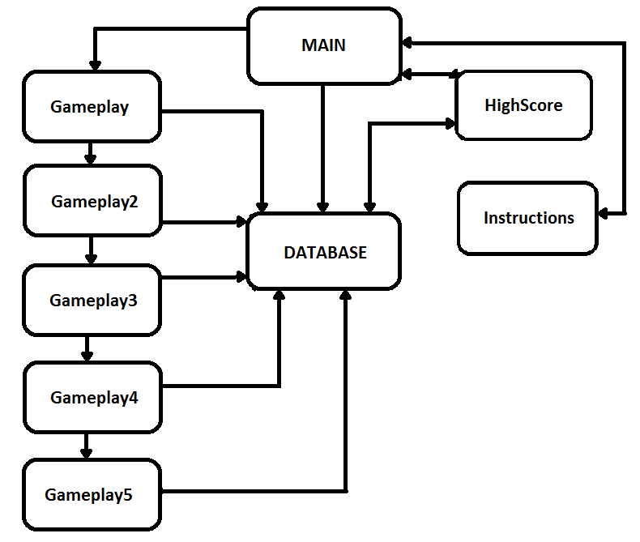

Fig 1. Project Design

This diagram is explains how the overall design of project. All rectangular diagram represents the class in the project except database. Database rectangle represents the database of the computer where all the information of player and their scores are storing.

**1.4 Working**

First of all when the project opens, the Main class will run because it contains main function.

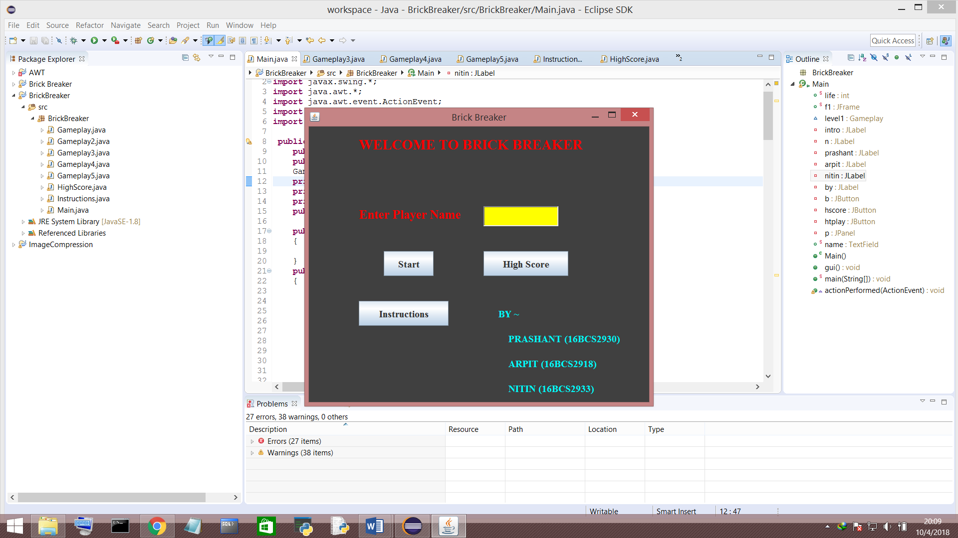

Fig. 2. Main Menu

This is the main menu. As you can see, there are three buttons and one textfield labeling ‘Enter Player Name’. Start button will start the game, High Score button will show the top ten scorers of all time and Instructions button will show the instructions of the game.

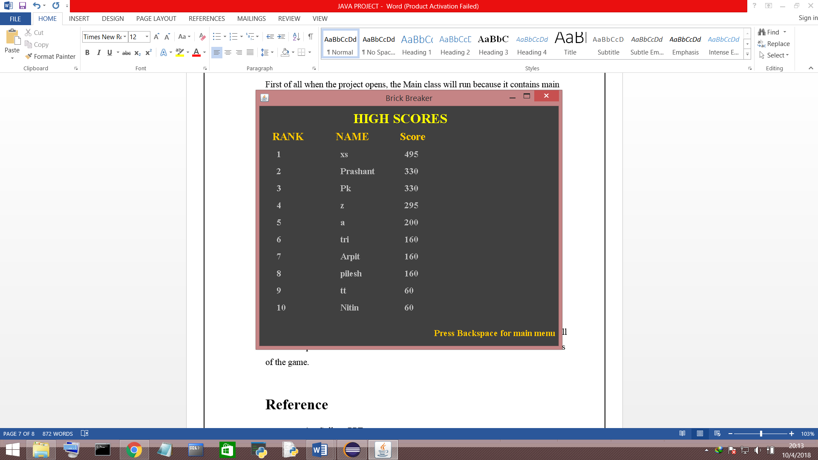

Fig. 3. After pressing High Score Button

To back to main menu user have to press Backspace key.

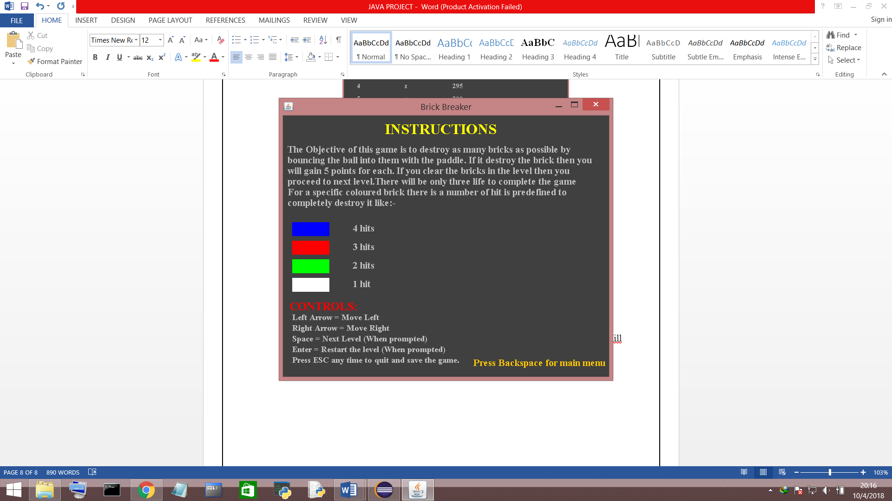

Fig. 4. After pressing Instruction Button

To back to main menu user have to press Backspace key.

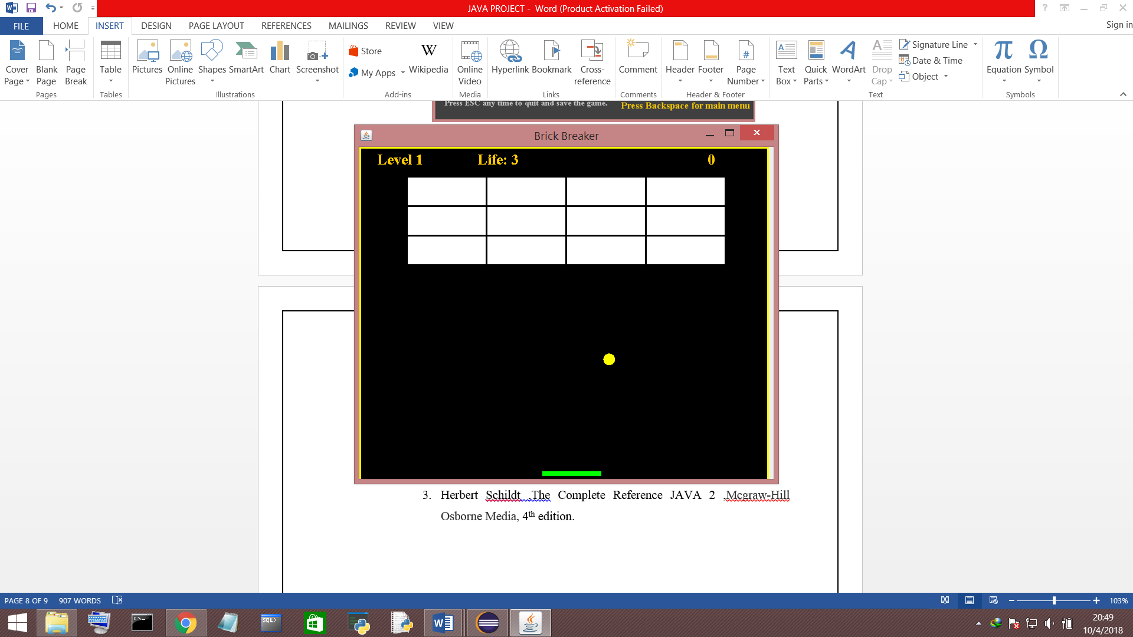

Fig. 5. After pressing Start first level Frame appears

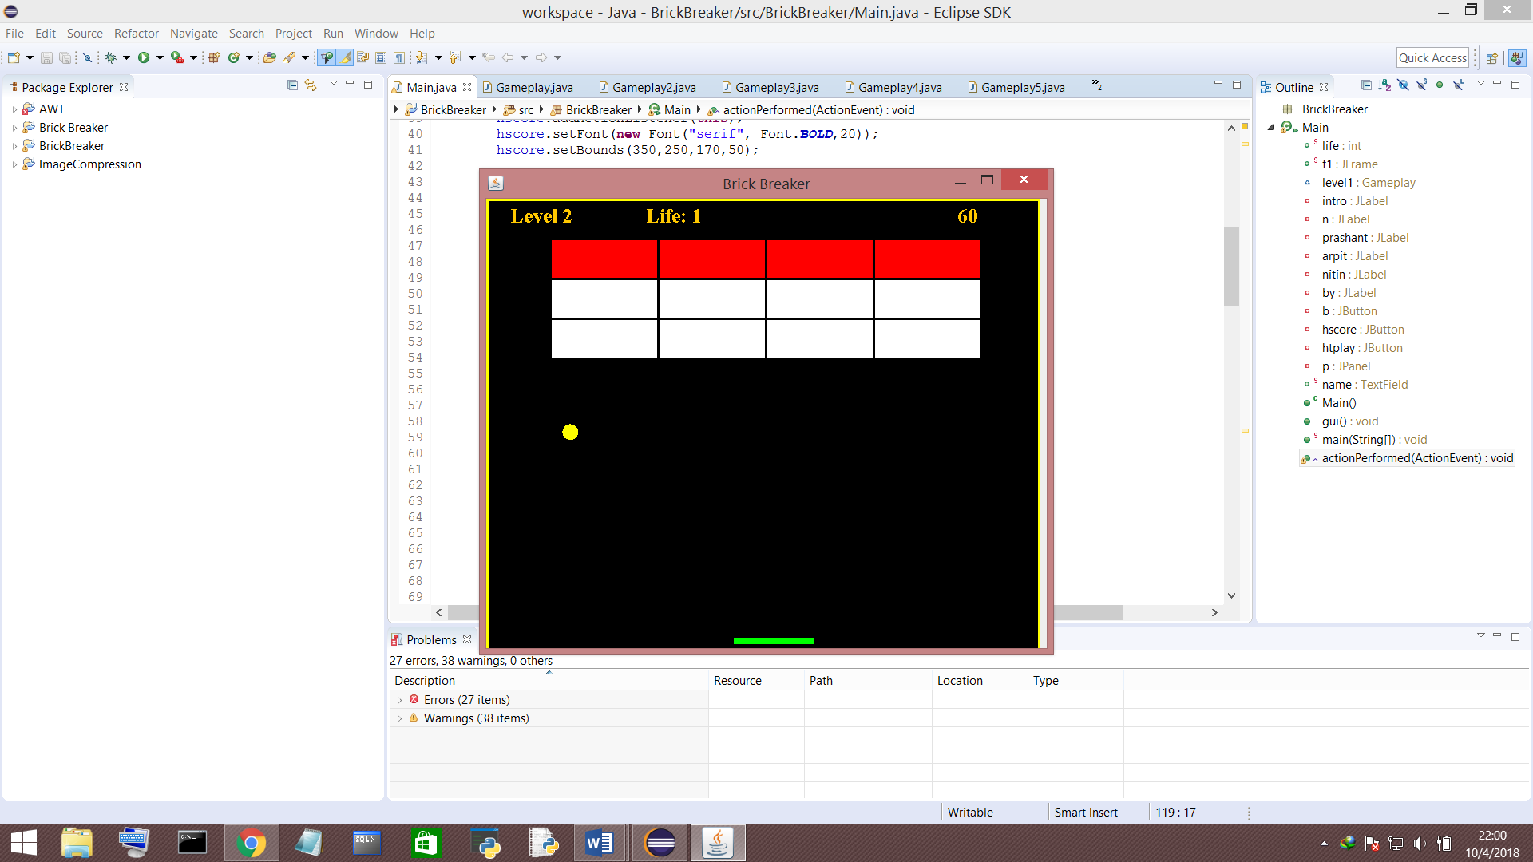

Fig, 6. After completing 1st level 2nd level panel appears

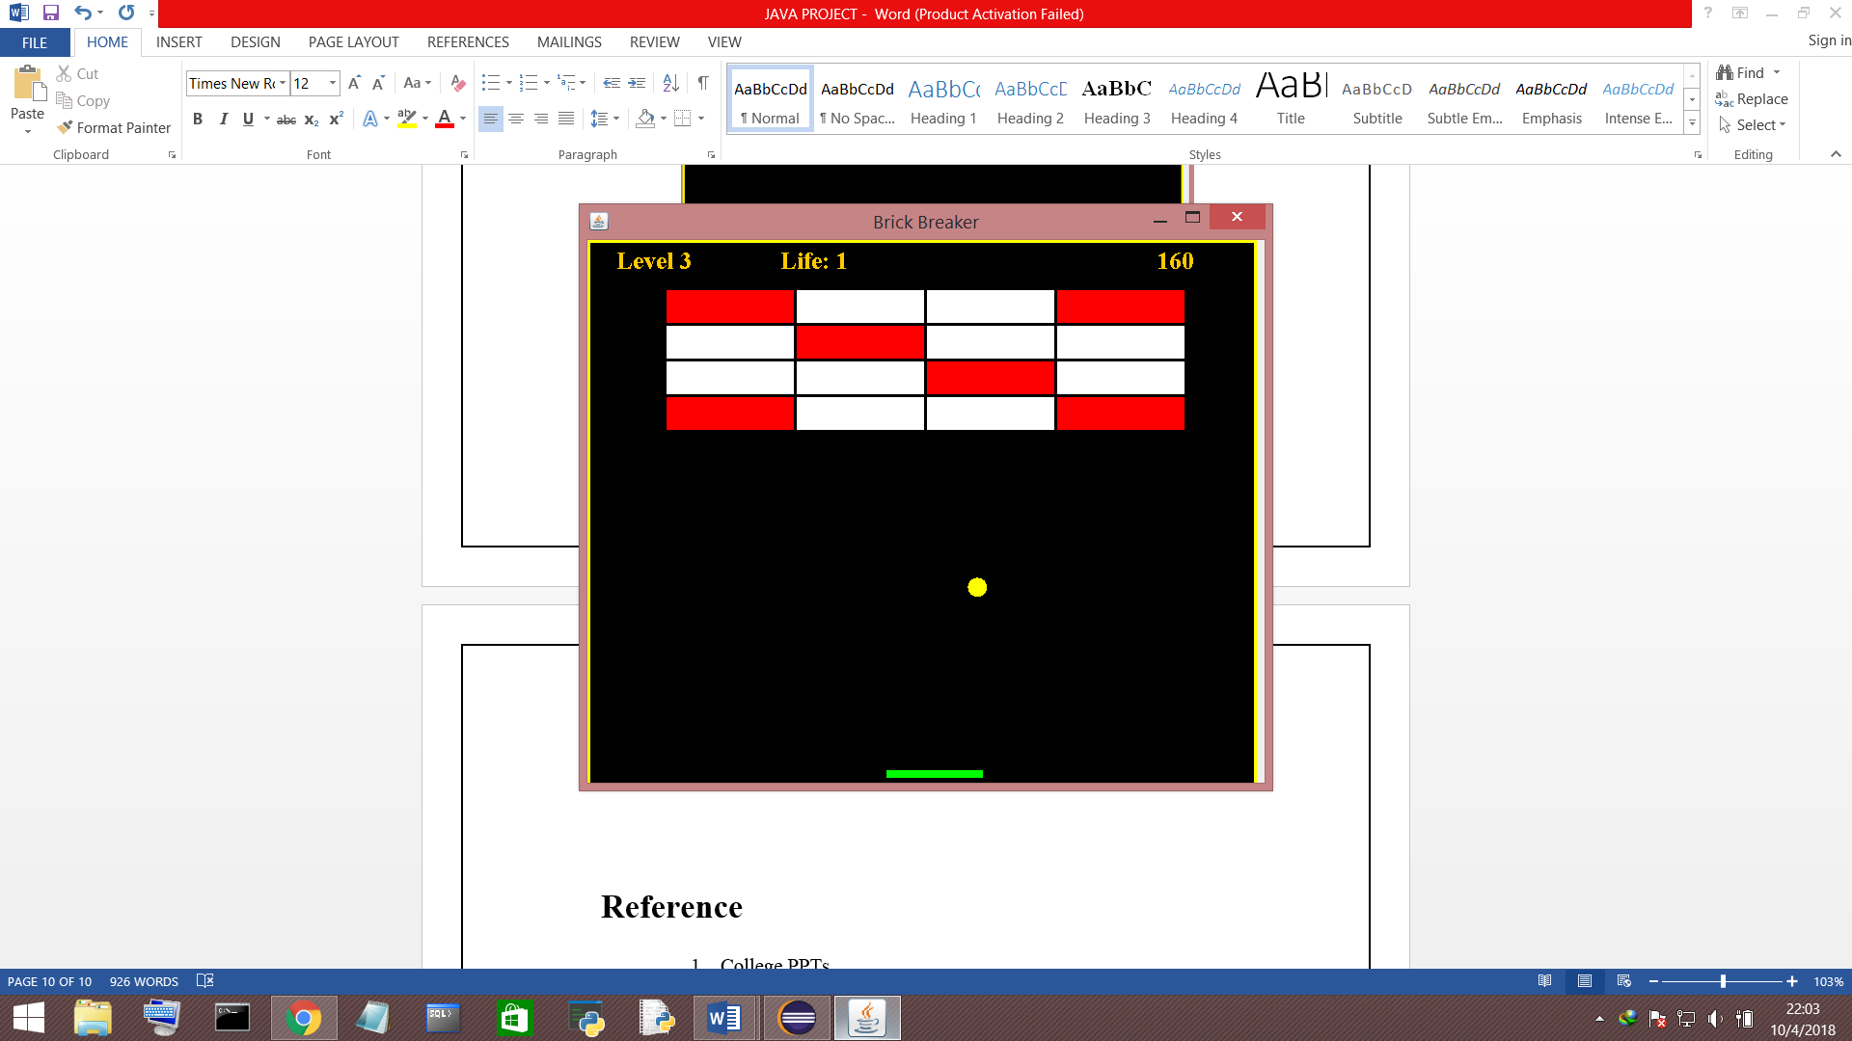

Fig. 7. After completing 2nd level 3rd level panel appears

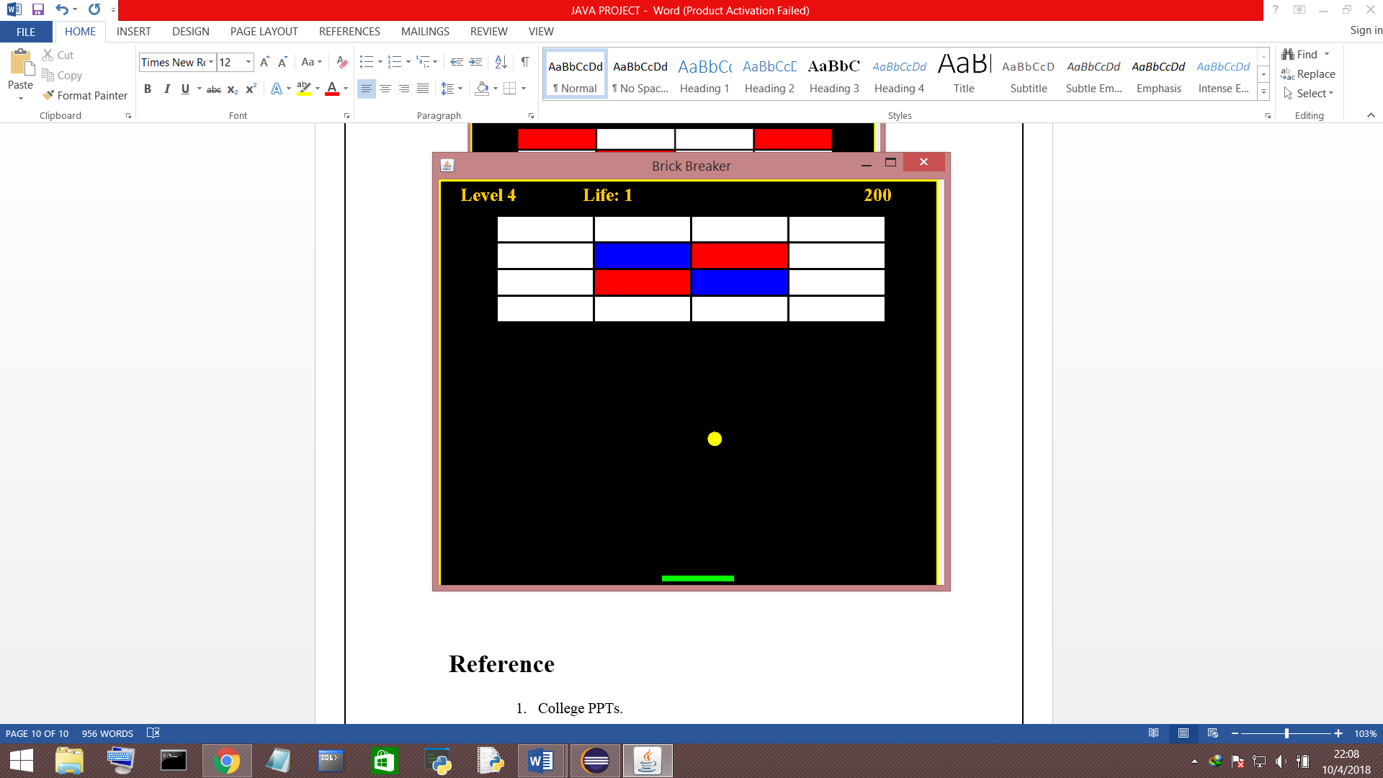

Fig. 7. After completing 3rd level 4th level panel appears

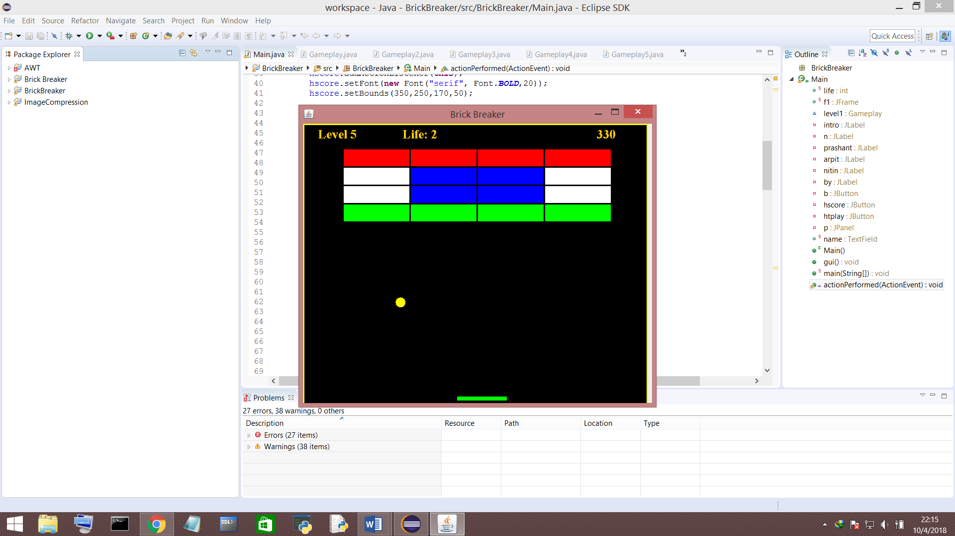

Fig. 7. After completing 4th level 5th level panel appears

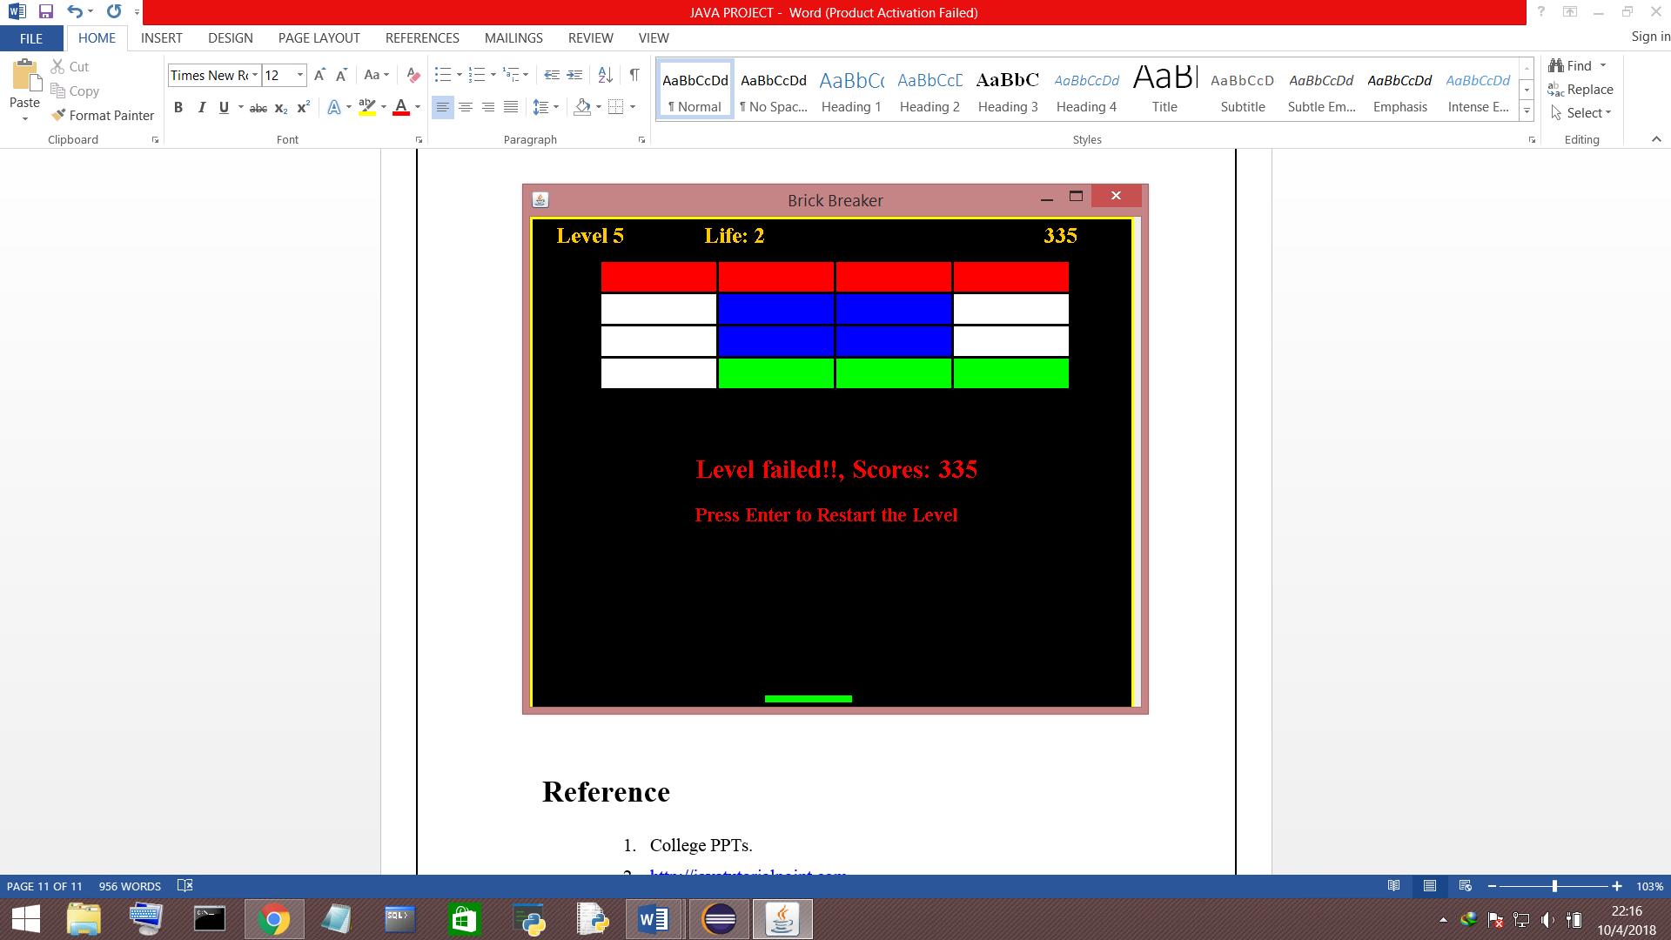

Fig. 8. If the user fails the level

**Reference**

* 1. College PPTs.
  2. <http://javatutorialpoint.com>
  3. Herbert Schildt ,The Complete Reference JAVA 2 ,Mcgraw-Hill Osborne Media, 4th edition.